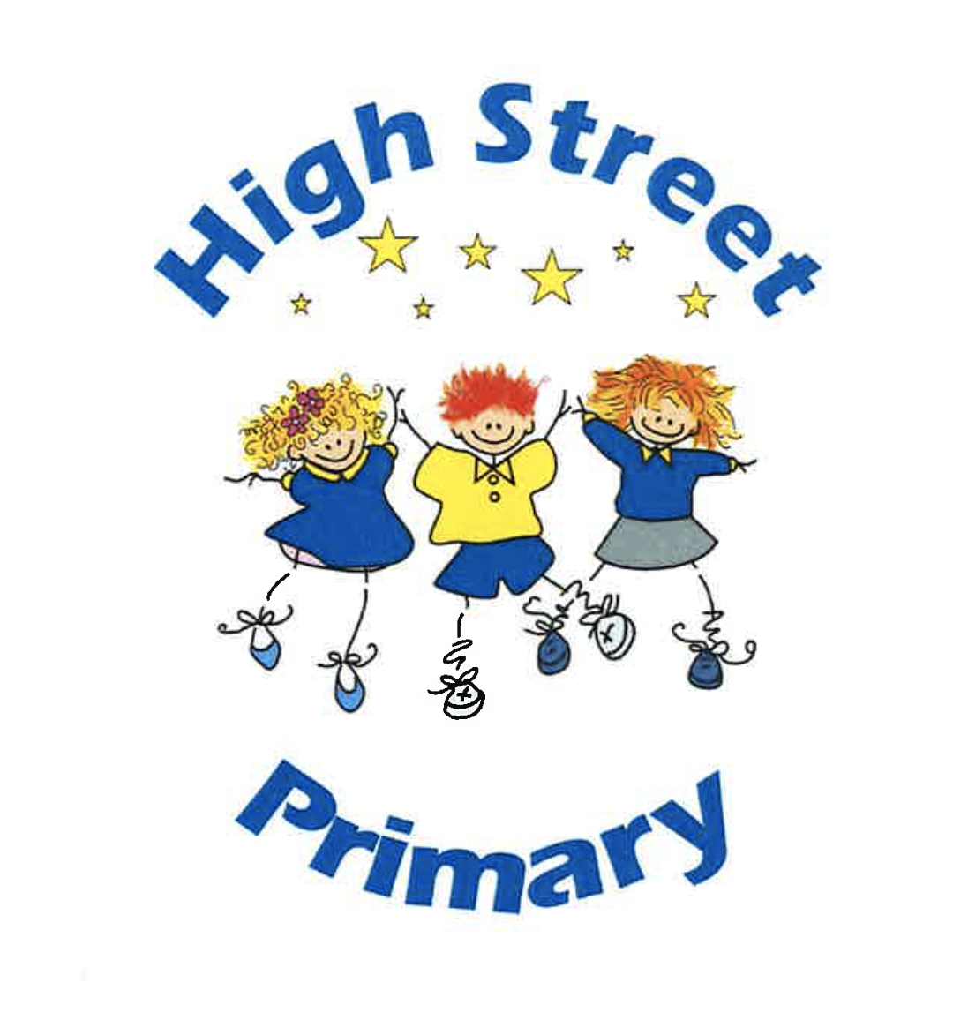
PARENTAL CONDUCT POLICY
Agreed by Governing Body: | September 2025
Review date: | September 2026
Person(s) Responsible: | Headteacher, Sarah McKee  Chair of Governors, Lucy Jones

HIGH STREET PRIMARY SCHOOL PARENTAL CONDUCT
MISSION
Our mission is to create a safe, secure and happy learning environment in the heart of our High Street Community, ensuring equality through enabling equity. All are encouraged to achieve their potential through a challenging, exciting and inclusive curriculum, enabling acquisition of skills for lifelong learning.

VISION
At High Street Primary School, all of our children will learn how to lead fulfilling lives as valued citizens of society, Wales and the wider world.

We will:
- Deliver the Curriculum For Wales through an innovative ‘Curriculum for High Street’ to ensure we develop ambitious and capable children ready to learn throughout their lives.
- Deliver rich tasks that ensure all children apply knowledge, skills and creativity so they are ready to play a full role in society.
- Immerse children in a variety of opportunities to produce healthy confident individuals who are aware of aspects of physical and mental health and wellbeing to enable them to lead fulfilling lives.
- In-still positive respectful values and develop children who are ready to be citizens of Wales and the World.

CODE OF CONDUCT

At High Street Primary School effective relationships are central to our achievements, supportive partnerships between parents, staff and the school community.
As a partnership, our parents understand the importance of good working relationships to equip their children with the necessary skills for adulthood. We continually welcome and encourage parents and carers to participate fully in the life of our school.
Effective relationships between home and school are based on the principles of care, integrity, trust and mutual respect. The maintenance of these relationships is important in order to ensure the duty of care we all hold with regard to safeguarding our children.
GUIDANCE
Parents, carers and visitors are reminded:
- To respect the caring ethos and values of the school.
- That both teachers and parents need to work together for the benefit of their children.
- Approaching school staff for help to resolve an issue is done in an appropriate manner.
- All members of the school community are treated with respect using appropriate language and behaviour.
- As a school, in line with a restorative approach and where appropriate, children will be fully involved in finding solutions to rising issues.
- To correct their child’s actions, especially where it could lead to conflict, aggressive or unsafe behaviour – both on and off the school premises.

In order to support a peaceful and safe school environment, we will not tolerate parents, carers or visitors exhibiting the following:
- Disruptive behaviour which interferers or threatens to interfere with any of the schools operations or activities anywhere on the school premises.
- Any in-appropriate behaviour on the school premises.
- Using loud or offensive language or displaying temper.
- Threatening, in anyway, a member of staff, visitor, fellow parent / carer or child.
- Damaging or destroying school property.
- Sending abusive or threatening emails or text / voicemails / phone messages or other written communications to anyone within the school community.
- Defamatory, offensive or derogatory comments regarding the school or any of the pupils / parents / staff, at the school on Facebook or other social sites (See Appendix 1)
- The use of physical or verbal aggression towards another adult or child.
- Approaching someone else’s child in order to discuss or chastise them because of the actions of this child towards their own child. Such an approach to a child may be seen to be an assault on the child and so may have legal consequences.
- Smoking, taking illegal drugs or the consumption of alcohol on school premises.
- Dogs being brought on to the school premises (other than guide dogs).
Should any of the above occur on the school premises, the school may feel it necessary to take action by contacting the appropriate authorities and / or sadly considering not allowing the offending adult to enter the school premises.
Thank you for abiding by this policy in our school, working with us to ensure our children experience a safe, secure and happy learning environment in the heart of our High Street Community
Note: Please share with all persons responsible for collecting your children.
APPENDIX 1
RAISING CONCERNS
All concerns are valid, particularly where causing individuals distress or anxiety. All concerns will be dealt with fairly, appropriately and effectively for all concerned. Most concerns can be settled quickly by speaking to the relevant person in school - class teachers, a member of the senior leadership team or the Head teacher. If you are not happy with the response provided, please refer to our Complaints Procedure.
IN-APPROPRIATE USE OF SOCIAL NETWORK SITES
Social media websites are being used increasingly to fuel campaigns and complaints against schools, Head teachers, school staff, and in some cases, other parents or pupils.
The Department for Education / Government and Governors of High Street Primary School consider the use of social media networks being used in this way as unacceptable. Any concerns you may have about the school, your child / children can be made directly to staff or through the school Complaints Procedure, available on our school website or directly from the office.
Slanderous or Derogatory Posts
In the event that any pupil or parents / carer of a child / children at High Street are found to be posting slanderous or derogatory comments on any social network site, they will be reported to the appropriate ‘report abuse’ section of the network site. All social network sites have clear rules about the content which can be posted on their sites, providing robust mechanisms to report contact or activity which breaches this. The school will also expect that any parent /carer or pupil removes such comments immediately.
Cyber Bullying
Online bullying is bullying using technology or online services or platforms, e.g. gaming, social media, messaging services, forums and chatrooms.

Online bullying can include threatening behaviour, abuse, harassment, shaming, exclusion, identify theft, malicious damage, non-consensual sharing of images/videos and coercion.
Bullying may target someone’s appearance, their sexuality, a disability, their culture, religion, social status and other characteristics. It can impact the health, well-being and self-confidence children and young people causing them to become more withdrawn, stressed and anxious.
We take very seriously the use of cyber bullying by one child or a parent to publicly humiliate another by inappropriate social network entry. We will take and deal with this as a serious incident of school bullying.
As a school, we will also consider our legal options to deal with any such misuse on social networking or other sites.
https://hwb.gov.wales/zones/keeping-safe-online/
Thank you for taking time to read this policy.
Reviewed Annually. Monitoring ongoing.

