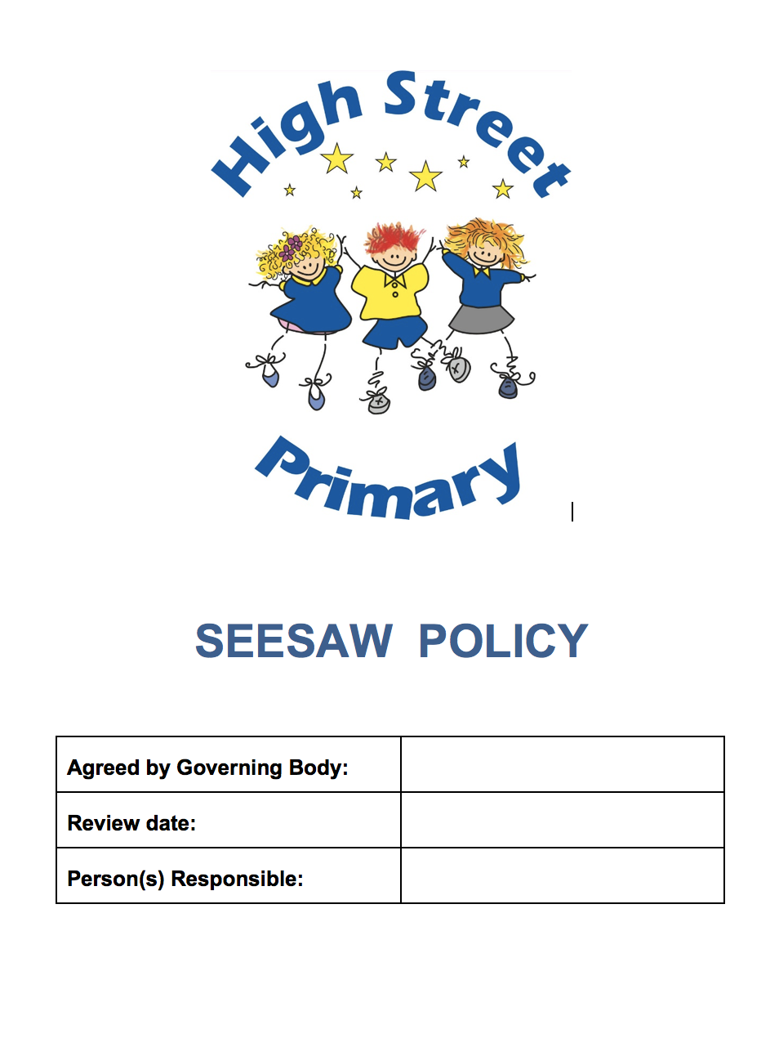


High Street Primary School
SeeSaw Policy

Reach for the Stars by Learning and Growing Together
Cyrraedd y sêr trwy ddysgu a thyfu gyda'i gilydd

AIMS AND OBJECTIVES
- To ensure all work is being evidenced
- To ensure all Teachers are confident in uploading work, tagging skills and assessing work
- To ensure children have access to a broad, balanced and creative curriculum
- To provide clear and consistent teaching throughout the school

SEESAW ACCOUNTS
When a child joins High Street Primary every child will be given 2 SeeSaw accounts – one for in class use and one for home use. It is the Class Teacher’s responsibility to email the SeeSaw coordinator to have these accounts added.

HOW WILL SEESAW BE USED IN THE CLASSROOM?
- All practical tasks planned by the Class Teacher should be evidenced on the SeeSaw platform e.g. pictures of practical Maths activities, oracy work etc. – this will create a digital record of pupil’s work.
- At the end of the academic year the class will be passed “up” rather than archived this will create a learning journal from when a child enters to the school to when they leave
- There is no need to upload work which is in their workbooks
- In Progression Steps 1 & 2 the adults in the classroom will be responsible for uploading pictures on to SeeSaw. In Progression Step 3 the children can be taught how to upload pictures themselves.

PLANNING
When planning on Building Blocks it should be evident on the planning if the learning will be evidenced on SeeSaw rather than in a work book.

ASSESSMENT
- All skills from the new curriculum have been uploaded on to the SeeSaw platform. These should be tagged on the photos using the “graduation hat” button. This will allow you to see coverage of each skill across the year.
- Every class has been assigned the skills associated with their Progression Step.
Nursery & Reception – Progression Step 1
Year 1, Year 2 & Year 3 – Progression Step 2
Year 4, Year 5, Year 6 & Y Bont – Progression Step 3
- You can search for key words when looking for skills to tag e.g. searching “add” to bring up the addition skills for your progression step
- On each piece of work the learning objective should be made clear. This could be added as a text box on the photograph for example.
- There is a 3 star rating system which can be used to assess against the learning objective e.g.

Achieved with a lot of support

Achieved with very little support

Achieved independently and working beyond expected level

HOME LEARNING
In Progression Steps 1 and 2 SeeSaw will be used to upload homework once a week.
Teachers will be expected to respond to the children’s work using the “like” button and the comment section. These do not need to be detailed responses but celebrate the effort the children have made.

MONITORING
SeeSaw will be monitored whilst completing reviews of learning.

MONITORING AND REVIEW
This policy will be reviewed annually or as needed in line with practice.

