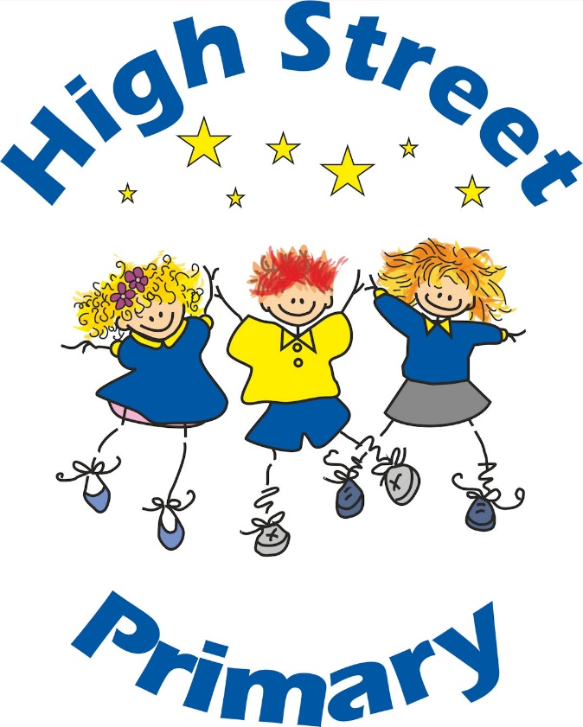

SCHOOL UNIFORM POLICY

Agreed by Governing Body:

Review date:

Person(s) Responsible:

SCHOOL UNIFORM POLICY
At High Street Primary School it is our policy that all children should wear school uniform when attending school, or when participating in a school-organised event outside normal school hours. We provide a complete list of the items needed for school uniforms in the attached APPENDIX.
AIMS AND OBJECTIVES
Our policy is based on the conception that a school uniform:
● promotes a sense of pride in the school;
● stimulates a feeling of community and belonging;
● is practical and smart;
● identifies the children with the school;
● is not distracting in class (as fashion clothes might be);
● makes children feel equal to their peers in terms of appearance;
● is regarded as suitable, and good value for money;
● has been considered with health and safety in mind.
JEWLLERY
On health and safety grounds, we do not allow children to wear jewellery in our school with the exception of small studs which must be removed for PE.
FOOTWEAR
We believe children should not be hindered by inappropriate footwear in their daily play or during physical activity. We believe that it is dangerous for children to wear shoes with platform soles or high heels. We encourage all children to wear the types of shoes described in the uniform list (APPENDIX 1).
HAIR STYLES AND ACCESSORIES
Children should wear their long hair tied back for P.E, practical science and cookery sessions. Please ensure your child has a hair bobble in their school bag for such occasions.
THE ROLE OF PARENTS AND CARERS
We ask all parents and carers who send their children to our school to support the school uniform policy. We believe that parents and carers have a duty to send their children to school correctly dressed and ready for their daily learning experiences. Parents and carers should ensure that their child has the correct uniform, and that it is clean and in good repair.
If any parent would like the school to modify the uniform policy, they should make representation, in the first instance, to the Head teacher. The school welcomes children from all backgrounds and faith communities. If there are serious reasons, e.g. religious objections, why parents and carers want their child to wear clothes that differ from the school uniform, the school will look empathetically at such requests. Similarly, should an item of school uniform prove problematic for a pupil with disabilities, then parents and carers are invited to draw this to the attention of the Head teacher.
LABELLING
We ask all parents to ensure all uniform is clearly labelled with your child’s full name.
AFFORDABILITY
The Governing Body considers the following when keeping down the cost of school uniform:
- The school will only stipulate basic features of the school uniform, for example, colour, so that school uniform can be purchased from multiple suppliers;
- Although the school does have a logo on jumpers and polo shirts, this is not compulsory; Second-hand school uniform sales will be enabled throughout the academic year.
- If you have any financial challenges with the purchase of a school uniform, please contact the school office.
EQUALITY
Our school uniform policy is inclusive and does not discriminate on the basis of gender and sex identity. As such, the school does not stipulate which items of uniform need to be worn by boys or girls.
EXTREMES OF WEATHER
The Governing Body take a common sense approach to the uniform policy when there is extreme weather. For example, pupils are allowed to wear shorts in the hotter weather and boots in cold weather.
ROLE OF GOVERNORS
The governing body supports the Head teacher in implementing the school uniform policy. It considers all representations from parents and carers regarding this policy, and liaises with the Head teacher to ensure that the policy is implemented fairly and with sensitivity.
It is the governors' responsibility to ensure that the school uniform meets all national regulations concerning equal opportunities, and that our school uniform policy is consistent with our policy on equal opportunities.
Governors ensure that the school uniform policy helps children to dress sensibly, in clothing that is hard wearing, safe and practical.
MONITORING AND REVIEW
When monitoring this policy, through its committee work, the governing body will:
● seek the views of parents and carers, to be sure that they agree with the policy, and support it;
● consider with the Head teacher any requests from parents or carers for individual children to have special dispensations;
● require the Head teacher to report to the governors on the way in which the policy is being implemented.

This policy will be reviewed every two years, or earlier if considered necessary.

APPENDIX
SCHOOL UNIFORM
- Black or grey trousers or shorts, skirts or pinafore dresses
- Yellow polo shirt
- Royal blue jumpers or cardigans
- Royal blue & white gingham dresses / skorts
- Royal Blue tights or grey tights
- Royal blue, grey or white socks,
- Black shoes, trainers or boots (no heel)
- Royal blue jumpers, cardigans and Year 6 Hoodies with school badge available to purchase from school.
PE KIT
- Royal blue or black joggers, leggings or shorts
- White t-shirt,
Royal blue or black zip-up top or hoodie
- Trainers

